A DAY AT WIMBLEDON – WEDNESDAY 4TH SEPTEMBER 2024

Elliswick Lawn Tennis Club is one hundred years old this year.
The Club was invited by the All England Lawn Tennis Club to participate in its Centenary Clubs Tournament at the Wimbledon Championship Courts on 4th September. A total of eight clubs from all over England as well as Scotland and Wales, took part. Elliswick’s Chairman, Eric Rovick, said, “The opportunity to play tennis on Wimbledon’s famous grass courts was fantastic. Andy Murray’s club from Dunblane played in the tournament and we had the pleasure to meet Jamie Murray on the day.”
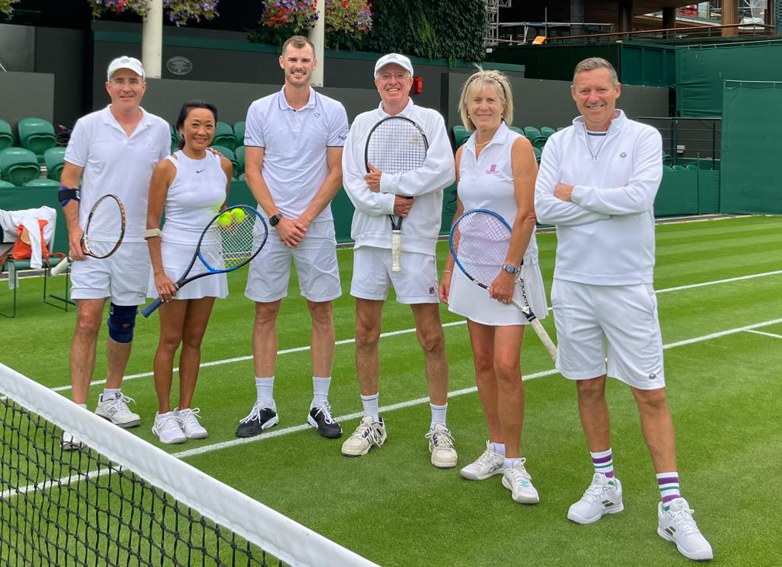
Eric Rovick, Andree Haxton (Elliswick), Jamie Murray, Alastair Heapy (Moor Park TC), Vivien Mrowiec (Moor Park TC) and Dan Bloxham (Wimbledon Head Coach)
The day at Wimbledon included tours of the grounds and museum, and a champagne reception and dinner in the Centre Court clubhouse.
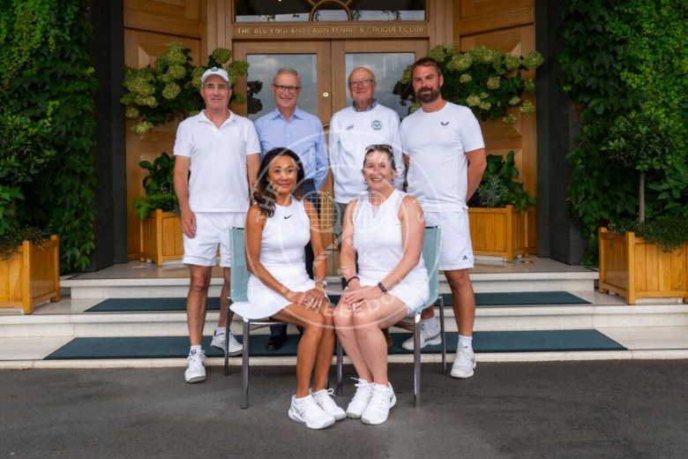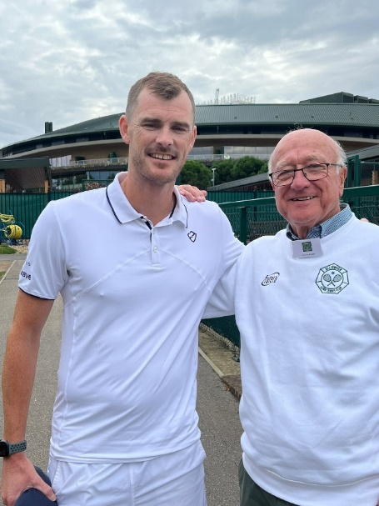
E Rovick (Chairman), D Kendall (Secretary), J McGown (President), Jamie Murray & Jim McGown (Club President)
B Wood (Head Coach), A Haxton (Administrator), K Curson (Ladies Captain)

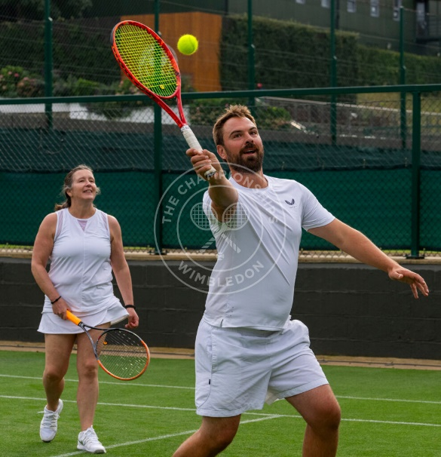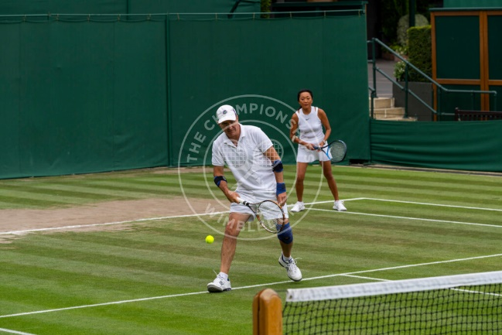
Kate Curson (Ladies Captain) & Ben Wood (Head Coach) Eric Rovick (Chairman) & Andree Haxton (Administrator & Welfare Officer)
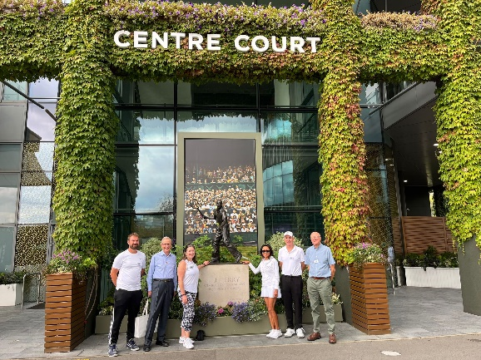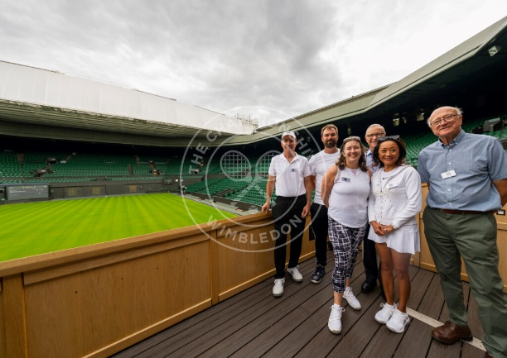

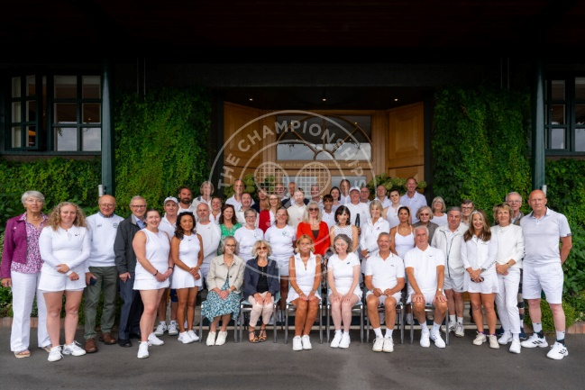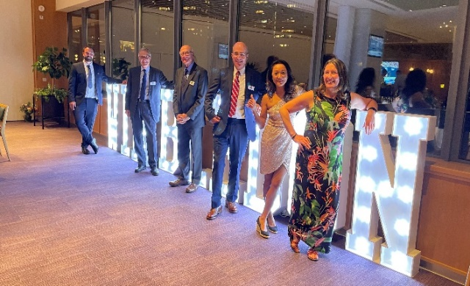

Elliswick will conclude its centenary celebrations with a dinner dance in October.

