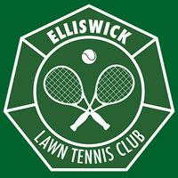
ELLISWICK LTC
CLUB CHAMPIONSHIP 2023
24 June 2023

WINNERS & RUNNER UPS

 | MATCHES | WINNERS | RUNNER UPS
 | Ladies Doubles | Emma Hall & Maki Watanabe-Genoud | Gaby Thornton & Jenny Sheridan
 | Men’s Singles | Dan Watkinson | Cameron Burnett
 | Ladies Singles | Maki Watanabe-Genoud | Emma Hall
 | Men’s Doubles | Oliver Tresman & Rupert Tillbrooke | Cameron Burnett & Andrew Bonnington
 | Mixed Doubles | Kate Curson &  Sam Harrison | Maki Watanabe-Genoud & Andy Barker

